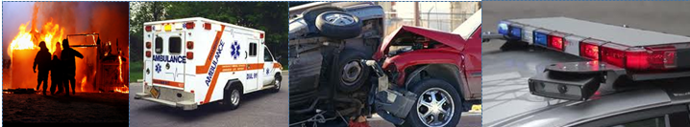
[Chiropractic Office] Proudly Serves Those Who Serve Our Community

When the weather turns bad and the power goes out, we rely on the first responders of [Community Name] to keep us safe and restore our lives to normal. Without the brave service of the Police, Firefighters, Emergency Squads and their support teams, the loss from life’s tragedies would be that much greater.

To say, “Thank You!” for all you have done and for all you will do in the future to protect our community, Dr. [Doctor’s Name] and the Wellness Team at [Office Name] would like to extend the offer of a Spinal Evaluation, done at our expense, to all of our First Responders in and around the [Town/City] Community during the month of September.

When the body’s “power” goes down because of spinal misalignment, your ability to perform at your optimum is lost. Chiropractic care helps the body to work at its best, free of the nerve system interference caused by spinal misalignments, so you can stay healthy and be your best when it counts - every moment of your life.

To take advantage of this offer and have your spine evaluated for the presence of spinal misalignments and nerve system interference, call our office and tell [Name of CA]:

“I Serve”
[Office logo and contact information here]

Allow us to serve you so you can be the best you, you can be.

Feel free to copy this letter and pass it on to your brothers and sisters in service.

To take advantage of this offer, call to schedule your screening appointment by September 30.

