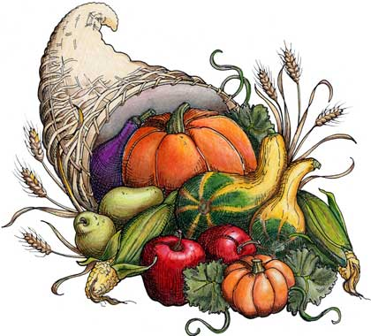
Help your community!
Join us as we hold our
ANNUAL FOOD & TOY DRIVE!
November 4th – December 5th

****All donations to benefit LOCAL families!!!****
This year for our toy drive our focus is a 7 year old boy from Lancaster who loves Minecraft, Skylanders, Science, Legos, Art & Technology!

Help your loved ones!
Food & Toy Drive Referral Program:
Refer any friend, relative, co-worker, or neighbor & they will receive a full examination (including x-rays if necessary) for the donation of
ONLY 1 un-wrapped toy or 10 non-perishable food items!
