To all our patients,

In compliance with our Virginia Governor Ralph Northam’s orders, our practice has provided all team members with face masks. It is according to the VA Department of Health and the CDC guidelines that the most important part of protection for ourselves and others is the social distancing and staying at home except for essential care including health care appointments. CDC defines close contact as within 6 feet and for a prolonged period of time 10 minutes or more.

It is the recommendation by CDC that people war face coverings particularly when in public and when they are not able to maintain the social distancing. Our practice as positioned the tables and seating to adhere to this spacing for ideal protection of all people. And most of the services we provide in our practice do not require prolonged close contact and thus we are in no way violating the Governor’s orders.

We hope that you know that everything we do in our practice is to provide you with the optimal patient experience. We are constantly reading and responding to the new orders and guidelines established so that we may continue to provide you and your family with the quality chiropractic care you are accustomed to receiving in our practice.

If there is any further conversation you would like to have with us, please feel free to schedule a time to talk with Dr Bob. We are here to serve you and in this time of pandemic we all need to be connected and communicating together.

Executive Order
NUMBER SIXTY-TWO (2020) AND ORDER OF PUBLIC HEALTH EMERGENCY FOUR JURISDICTIONS TEMPORARILY DELAYED FROM ENTERING PHASE ONE IN EXECUTIVE ORDER 61 AND PERMITTED TO REMAIN IN PHASE ZERO NORTHERN VIRGINIA REGION

Employers are required to provide face coverings to employees.
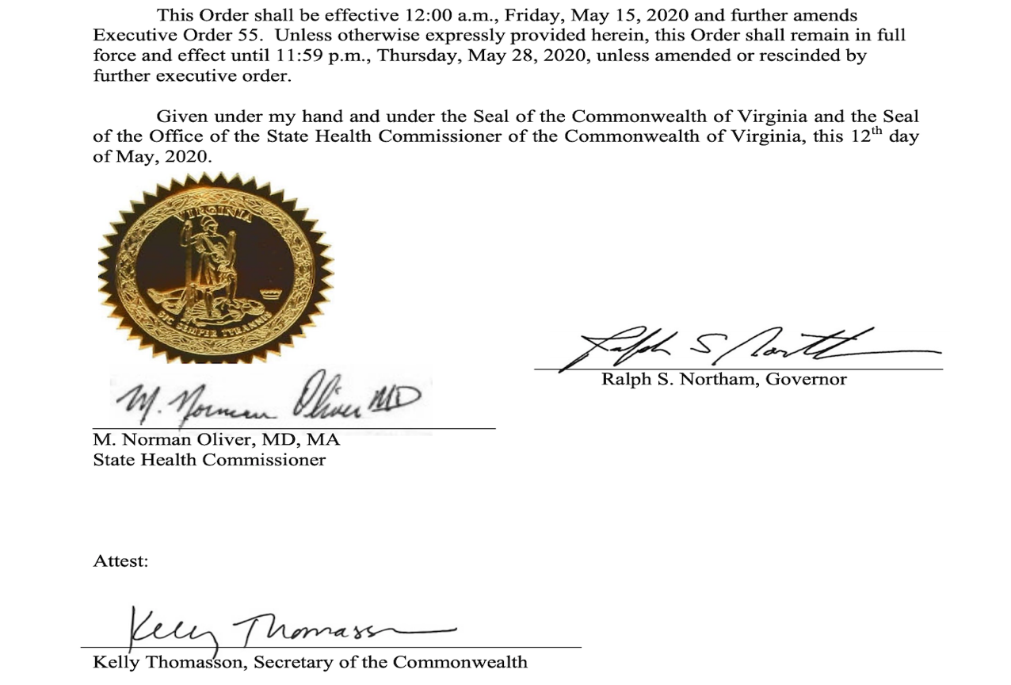

Interpretation: In the Virginia Beach region of VA we do not have “significant community based transmission.” With 509 positive cases and 18 deaths there is no evidence to imagine that there is a high risk in our community of transmission of the virus.

