Shining The Light
“Medicine is the study of disease and what causes man to die. Chiropractic is the study of health and what causes man to live.” B.J. Palmer
TLC Chiropractic values the relationships we have with each of you. We are making the best decisions with two goals in mind:
Our first goal is to ensure the best chiropractic care delivered to you without interruption while always providing that care in the safest possible environment. Chiropractic care is essential for life. There is no system with higher priority in the body than our nervous system. All body functions are controlled by the nervous system including our immunity. Removing interferences to our nervous system function is what we do as your chiropractors.
Our second goal is to stay connected by showing up for and with people. We are open to serve your family. We are responsive to our state public health updates and we make changes based upon what we are asked to do to be able to stay open and provide you with the best care. We are doing daily 6 minute videos of science shared in our Facebook group “TLC Chiro Family”. Watch them and share them with everyone you know. We are getting out in our community. We are calling all of you to see how we can support and help you individually. We will continue to come up with solutions beyond what has been expressed. We are praying for our families and for our leaders and the decisions that are being made. We are creative as these times require us to be present at a new level that none of us have experienced before.
You turn to us for help. We are here to provide you with information to help you get through this crisis with less worry and fear. At times like these, our belief systems about what health is and how we preserve it are challenged. Whatever you decide to do for you and your loved one’s health, it should be based in sound science, not the latest whim or fad and your decisions will be respected by us.
The COVID-19 / Corona / Wuhan Virus does what all viruses do: it invades and replicates itself inside of your own cells. It has a predilection for the respiratory system and lungs. The virus tends to most negatively affect the elderly and those with already compromised immune systems. It has few or no symptoms in the early phases of infection, but it can rapidly progress to severe symptoms quickly. No person wants or plans to get infected. Thankfully, there are both “offensive” and “defensive” steps you can take to lower your risk of exposure to and illness from this virus. Interestingly, these are the same steps we would recommend to reduce your risk of any infection.
Proactive steps you can take:
- Address the nervous system as the prime system to be addressed first. Get your spine checked and stay subluxation-free by getting adjusted. If you have friends and family who have not been checked this is the best time to bring them in.
Enhanced Phagocytic Cell Respiratory Burst Induced by Spinal Manipulation: potential role of Substance P JMPT 1991
https://www.ncbi.nlm.nih.gov/pubmed/1719112
- Pray
https://jamanetwork.com/journals/jamainternalmedicine/fullarticle/485161
- Follow basic hygiene protocols- wash your hands
Build your immunity so that your body has a better chance of being able to be in the 90+% of people worldwide who have currently recovered from the corona virus
- Eat healthy foods that build up and support your immune system
Key nutrients to combat viruses:
- Vitamin C (in the complex nature provides): viruses deplete vitamin C, but vitamin C is anti-viral, increases white blood cells, is necessary for the body to produce interferon, and reduces the risk of infections, especially in the lung; foods high in vitamin C include sauerkraut, bell peppers, leafy dark greens, and citrus fruits
- Vitamin E (in the complex nature provides): a fat-soluble vitamin which strengthens your immune system and is an antioxidant; foods high in vitamin E include avocado, nuts, seeds, and leafy greens
- Selenium (in the complex nature provides): a trace mineral that which strengthens your immune system and is an antioxidant; foods high in selenium include Brazil nuts, eggs, broccoli, spinach, asparagus, brown rice, oatmeal, garlic, salmon, beef and chicken
- Zinc (in the complex nature provides): nuts and seeds (including cashews, almonds, pumpkin seeds, watermelon seeds), grass-fed dairy, asparagus, spinach, dark chocolate, salmon, beef, chicken, oysters
- Vitamin D (in the complex nature provides, the best form being D-3): sunlight, cod liver oil, mushrooms, cheese, eggs, fatty fish, sardines
- Vitamin A (in the complex nature provides, the best form being beta-carotene): green leafy vegetables, sweet potatoes, carrots
- Key foods to avoid: white refined table sugar, processed grains, artificial sweeteners, fast food, alcohol
- Hydrate yourself well (minimum: body weight divided by 2 = # of ounces of pure water needed for minimum level)
- Get adequate sleep (most adults need 7-8 hrs/night, more if you are ill or stressed)
- Stay active (moderate exercise raises your core body temperature, which fights micro-organisms like a fever)
- Be sure to keep your sense of humor: Having a good laugh can do wonders to boost your immunity! https://www.ncbi.nlm.nih.gov/pmc/articles/PMC2686627/pdf/nem149.pdf?fbclid=IwAR2xsyJQH5F8QU7CpQxIZyYfFMqRtwYJfU3B9alNw5WS_HaxO3GbFowN-JE
Our commitment is and will always be to you and your families. We are here to serve and to help us all navigate these unprecedented times.
Thank you to our colleagues, Dr Linn Erickson and Dr Paul Firnhaber for sharing your knowledge and expertise on the proactive steps to take now and always for optimal health.
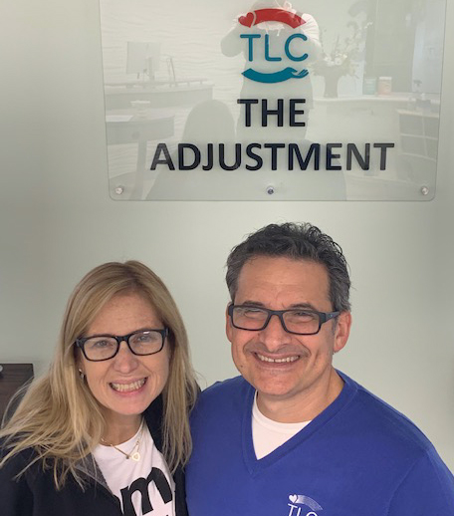
TLC Chiropractic / 215-657-3200 / 907 Easton Rd., Willow Grove, PA 19090
www.tlcchiro.life

Drs. Dean & Jen DePice
TLC Chiropractic

